HTML ASSIGNMENT

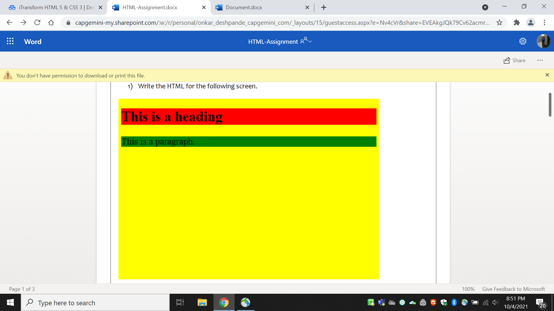

<!DOCTYPE html>

<html>

<body style="background-color:Yellow;" >

<h1 style="background-color:DodgerBlue;">This is a heading</h1>

<p style="background-color:Tomato;">This is a paragraph</p>

</body>

</html>

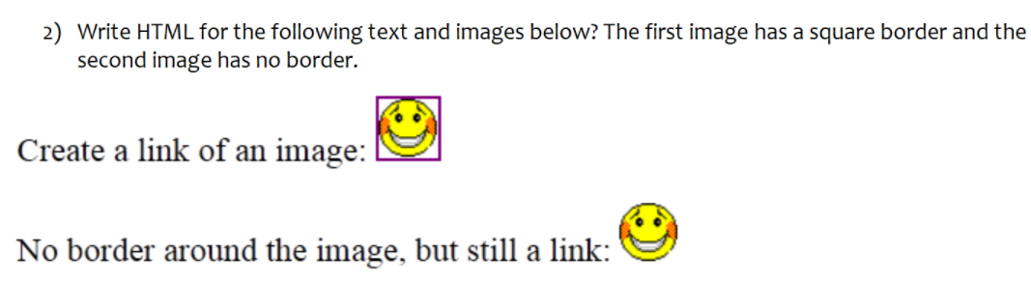

<!DOCTYPE html>

<html>

<body>

<label for=”image 1”>Create a link of an image:</label>

<img src=”square_border.jpg” id=”image 1” value=”image 1” >

<br>

<label for=”image 2”>No border around the image,but still a link:</label>

<img src=”without_border.jpg” id=”image 2” value=”image 2” >

</body>

</html>

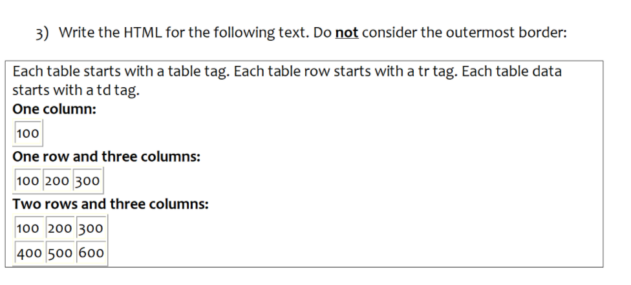

<!DOCTYPE html>

<html>

<head>

<style>

table,td {

border: 1px solid black;

border-collapse: collapse;

}

</style>

</head>

<body>

<p>Each table starts with a table tag.Each table roq starts with a tr tag.Each table data starts with a td tag.</p>

<p><b>One column:</b></p>

<table>

<tr>

<td>100</td>

</tr>

</table>

<p><b>One row and three columns:</b></p>

<table>

<tr>

<td>100</td>

<td>200</td>

</tr>

</table>

<p><b>Two rows and three columns:</b></p>

<table>

<tr>

<td>100</td>

<td>200</td>

<td>300</td>

</tr>

<tr>

<td>400</td>

<td>500</td>

<td>600</td>

</tr>

</table>

</body>

</html>

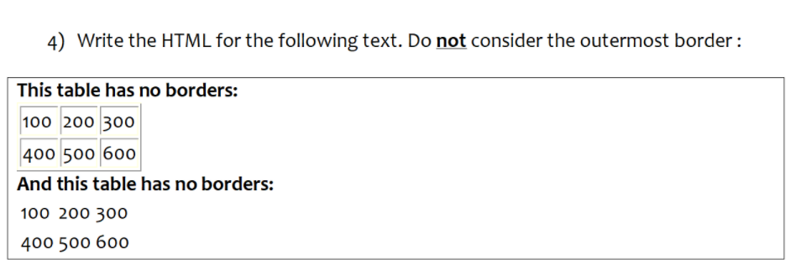

<!DOCTYPE html>

<html>

<body>

<p><b>This table has no borders:</b></p>

<table style="border: 1px solid black;border-collapse: collapse;">

<tr style="border: 1px solid black;">

<td style="border: 1px solid black;">100</td>

<td style="border: 1px solid black;">200</td>

<td style="border: 1px solid black;">300</td>

</tr>

<tr style="border: 1px solid black;">

<td style="border: 1px solid black;">400</td>

<td style="border: 1px solid black;">500</td>

<td style="border: 1px solid black;">600</td>

</tr>

</table>

<p><b>And this table has no borders:</b></p>

<table style="border: 0px solid black;">

<tr>

<td>100</td>

<td>200</td>

<td>300</td>

</tr>

<tr>

<td>400</td>

<td>500</td>

<td>600</td>

</tr>

</table>

</body>

</html>

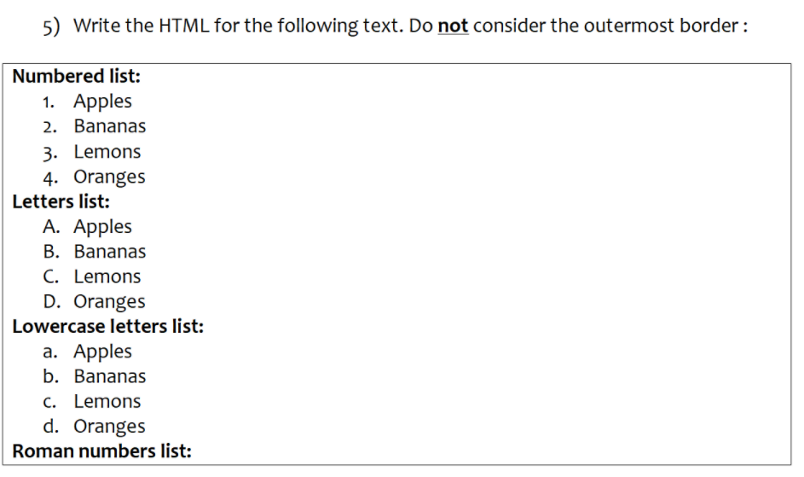

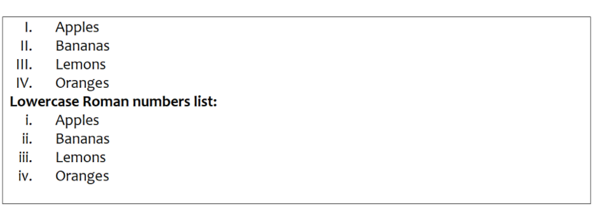

<!DOCTYPE html>

<html>

<body>

<h3>Numbered lists:</h3>

<ol type="1">

<li>Apples</li>

<li>Bananas</li>

<li>Lemons</li>

<li>Oranges</li>

</ol>

<h3>Letters lists:</h3>

<ol type="A">

<li>Apples</li>

<li>Bananas</li>

<li>Lemons</li>

<li>Oranges</li>

</ol>

<h3>Lowercase letters lists:</h3>

<ol type="a">

<li>Apples</li>

<li>Bananas</li>

<li>Lemons</li>

<li>Oranges</li>

</ol>

<h3>Roman numbers lists:</h3>

<ol type="I">

<li>Apples</li>

<li>Bananas</li>

<li>Lemons</li>

<li>Oranges</li>

</ol>

<h3>Lowercase Roman numbers lists:</h3>

<ol type="i">

<li>Apples</li>

<li>Bananas</li>

<li>Lemons</li>

<li>Oranges</li>

</ol>

</body>

</html>

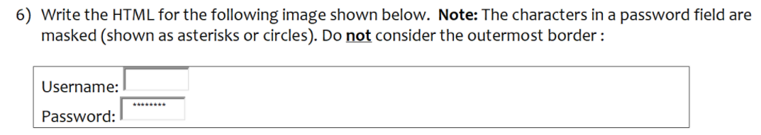

<!DOCTYPE html>

<html>

<body>

<form>

<label for="username">Username:</label>

<input type="text" id="username" name="username"><br>

<label for="pwd">Password:</label>

<input type="password" id="pwd" name="pwd"><br><br>

</form>

</body>

</html>

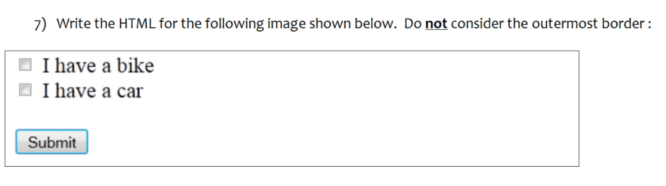

<!DOCTYPE html>

<html>

<body>

<form action="Submit">

<input type="checkbox" id="vehicle1" name="vehicle1" value="Bike">

<label for="vehicle1"> I have a bike</label><br>

<input type="checkbox" id="vehicle2" name="vehicle2" value="Car">

<label for="vehicle2"> I have a car</label><br>

<input type="submit" value="Submit">

</form>

</body>

</html>

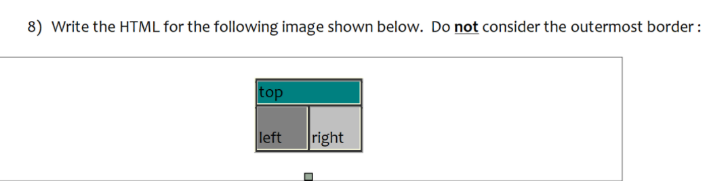

<!DOCTYPE html>

<html>

<body>

<table style="border: 1px solid black;border-collapse: collapse;">

<tr row span="2" bgcolor="green">

<th>Firstname</th>

</tr>

<tr style="border: 1px solid black;">

<td style="border: 1px solid black;" bgcolor="ash">Left</td>

<td style="border: 1px solid black;" bgcolor="grey">Right</td>

</tr>

</table>

</body>

</html>

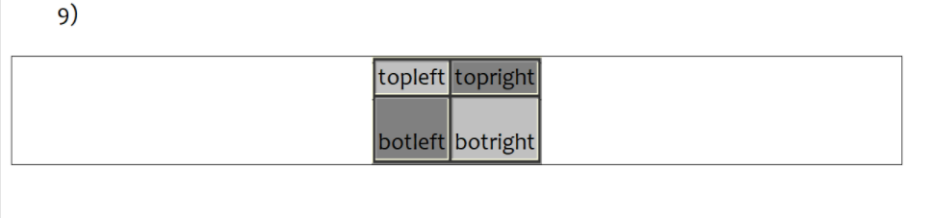

<!DOCTYPE html>

<html>

<head>

<style>

table,td{

border: 1px solid black;

border-collapse: collapse;

}

</style>

<head>

<body>

<table>

<tr>

<td bgcolor="grey">topleft</td>

<td bgcolor="ash">topright</td>

</tr>

<tr>

<td bgcolor="ash">botleft</td>

<td bgcolor="grey">botright</td>

</tr>

</table>

</body>

</html>